To Supply Leftover Food to Poor

(Salesforce-Based Food Redistribution and Management System)
Naan Mudhalvan Project



P.S.R.R College Of Engineering , Sivakasi

Team ID : NM2025TMID02981

Team Leader : Hariharan K

Team member : Mukesh Raj R Team member : Punitha Kishore T
Team member : Arun kumar S
- Ideation Phase:

Objective:

To create a Salesforce application that helps collect leftover food from venues (restaurants, hotels, events) and distribute it to poor people through registered volunteers and drop-off points.

Problem Statement:

Large amounts of food go to waste at events, hotels, and canteens. Poor people nearby remain hungry because there’s no proper system to redistribute surplus food effectively and safely.

Proposed Solution:

Develop a Salesforce-based solution that:

    - Tracks food availability from venues.

    - Uses volunteers to transport food.

    - Uses drop-off points as collection centers.

    - Monitors each task and execution detail to ensure completion and accountability.
    - Tracks the entire journey — Food Donated → Picked → Delivered →
Feedback Collected

Example:

An Event Hall (Venue) reports leftover food

↓

Salesforce assigns a nearby Volunteer

↓

Volunteer delivers it to a Drop-Off Point

↓

Food is distributed to the poor

↓

Execution Detail records the delivery completion

- Project Planning Phase:

Goals:
    - Automate the redistribution of leftover food.
    - Record every step (collection, delivery, distribution).
    - Provide dashboards for tracking and reporting.

  - Stakeholders:

Role | Description
Venue Manager | Uploads food availability data.
Volunteer | Handles pickup and delivery.
Drop-Off Point Manager | Receives and manages food distribution.
Admin | Oversees operations, users, and system  performance.

Tools in Salesforce:

    - Custom Objects: Venue, Drop-Off Point, Volunteer, Task, Execution Detail.
    - Automation Tools: Process Builder / Flows for assigning volunteers automatically.
    - Reports & Dashboards: For monitoring completed deliveries and total food saved.

Project Design Phase – Data Model and Workflow:

Object | Description | Relationships
Venue | Stores donor info (restaurants, hotels,  events). | One Venue → Many Tasks
Drop-Off Point | Locations where food is delivered (NGOs,  shelters). | One Drop-Off → Many Execution Details
Volunteer | Registered individuals  for pickup/delivery. | One Volunteer → Many  Tasks
Task | Represents  pickup/delivery work  assigned. | Linked to Venue,  Volunteer, and Drop-Off Point
Execution Detail | Stores results of the  completed delivery. | Linked to Task

  - Workflow Automation:

    - When Venue adds new leftover food → Salesforce creates a Task automatically.
    - Based on location and time, system assigns a Volunteer.
    - After completion, Volunteer updates the Execution Detail record.
    - Admin can view reports showing all completed deliveries.

E-R Diagram:

[Venue]
↓

[Task]
↙ ↘

[Volunteer] [Drop-Off Point]
↓
[Execution Detail]
- Requirement Analysis Phase:

- Functional Requirements:
These define what the system must do. For example, it allows venue managers to add leftover food details, automatically creates tasks, assigns volunteers, tracks delivery to drop-off points, and records final execution details with feedback.

- Non-Functional Requirements:
These describe how the system should perform. It ensures security through role-based access, maintains data accuracy, supports scalability for many users, automates processes to save time, and provides fast dashboard performance within 3 seconds.

Salesforce developer account creation:
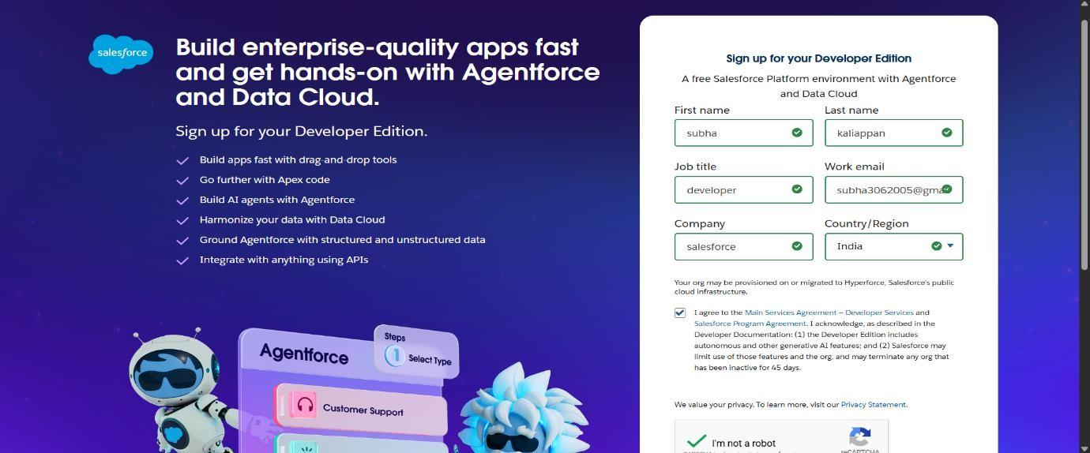
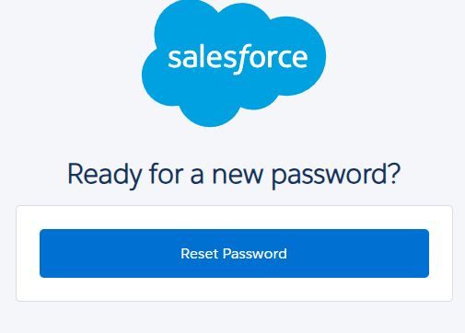

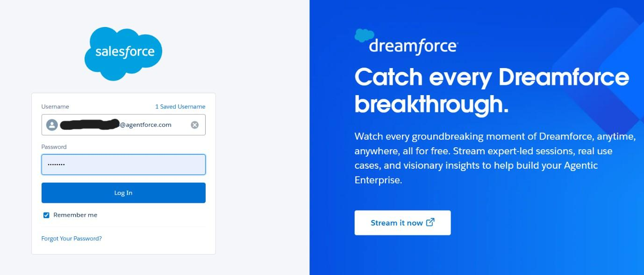

Create a Object:
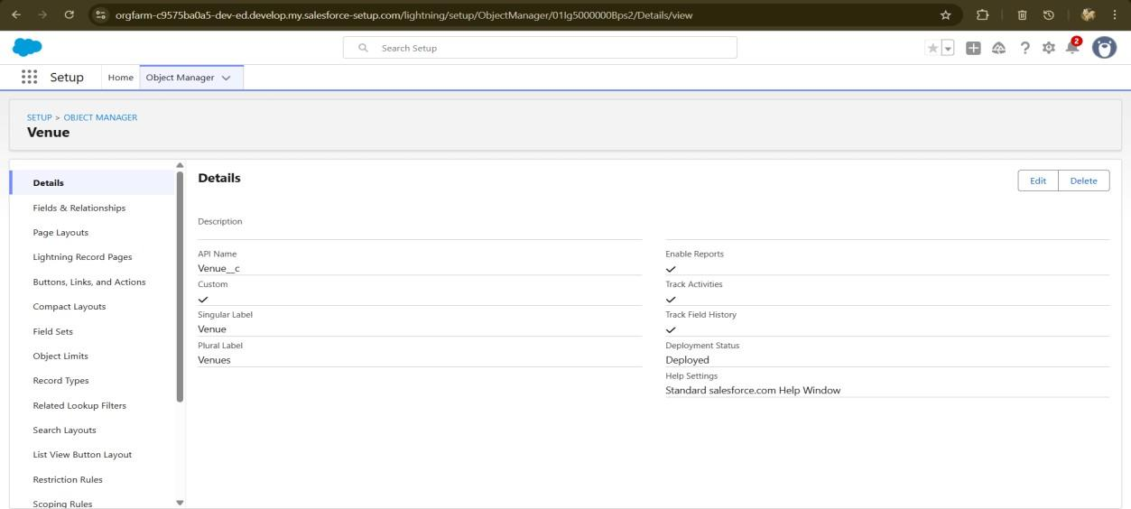
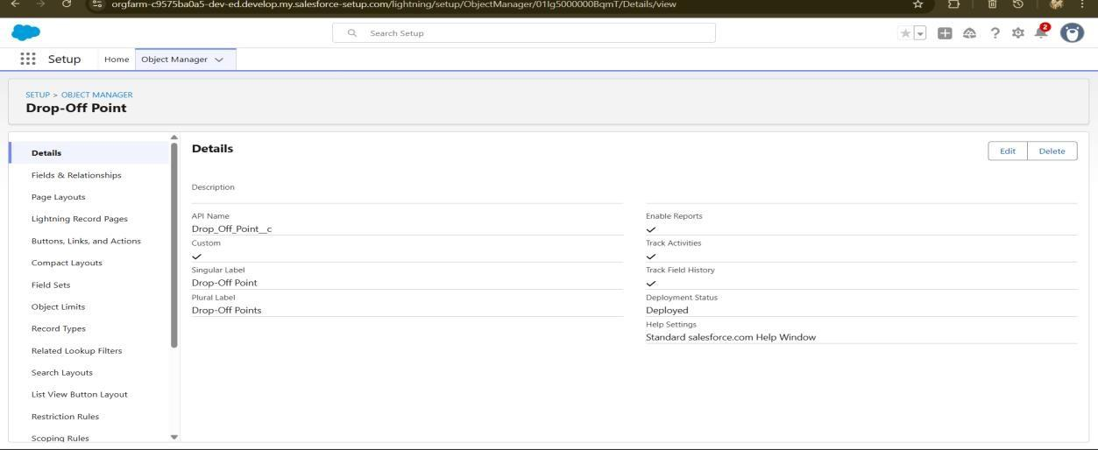
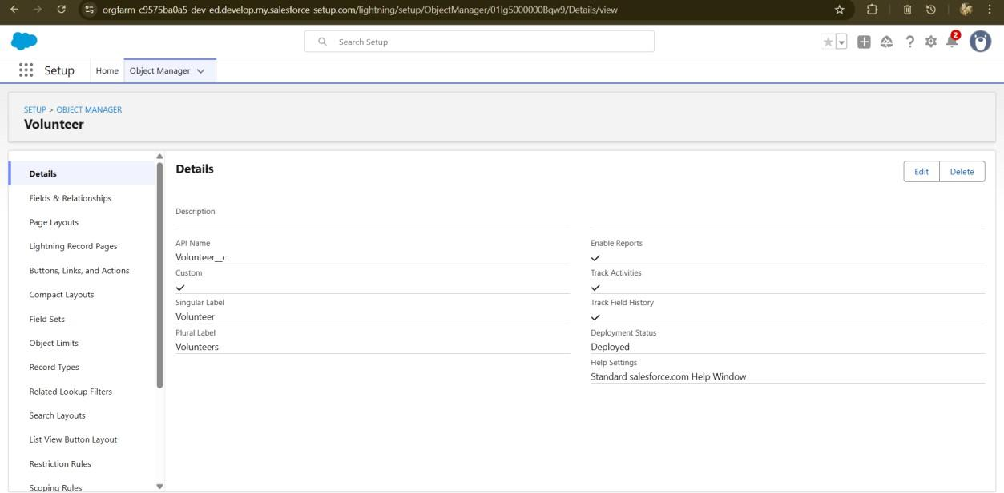

Creating a Custom Tab:
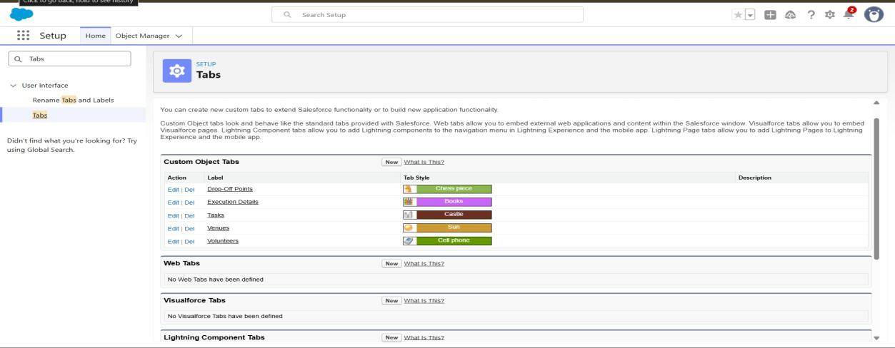
Create a Lightning App:
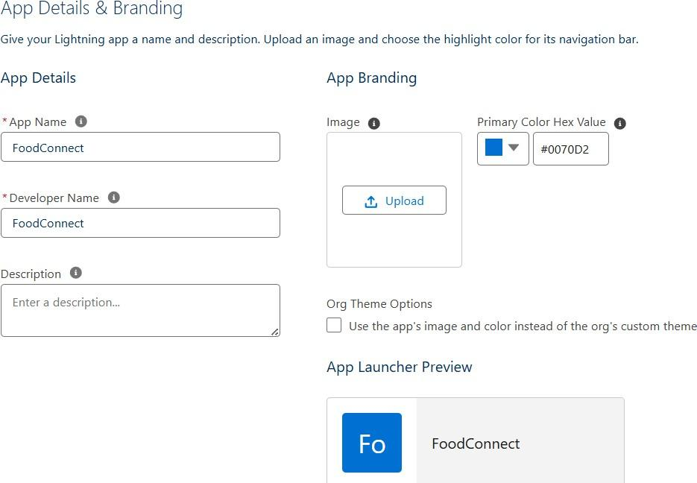

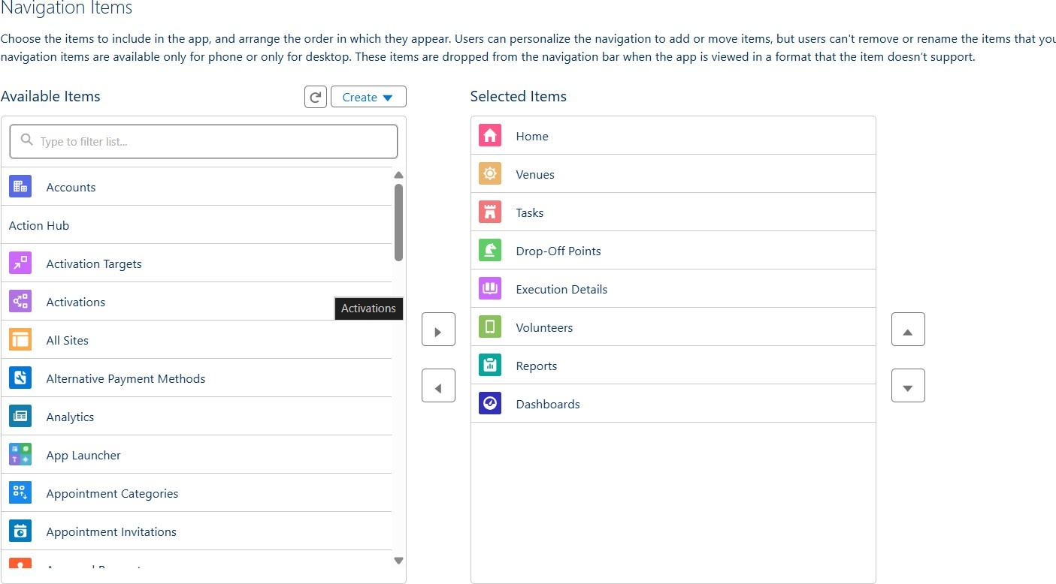
Creation of Relationship fields in objects:

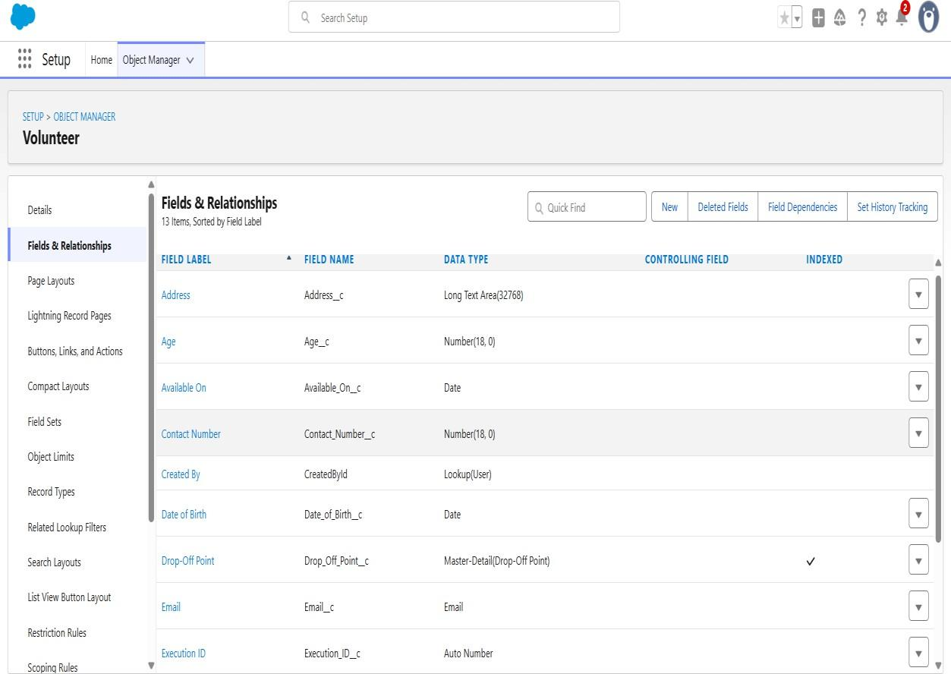

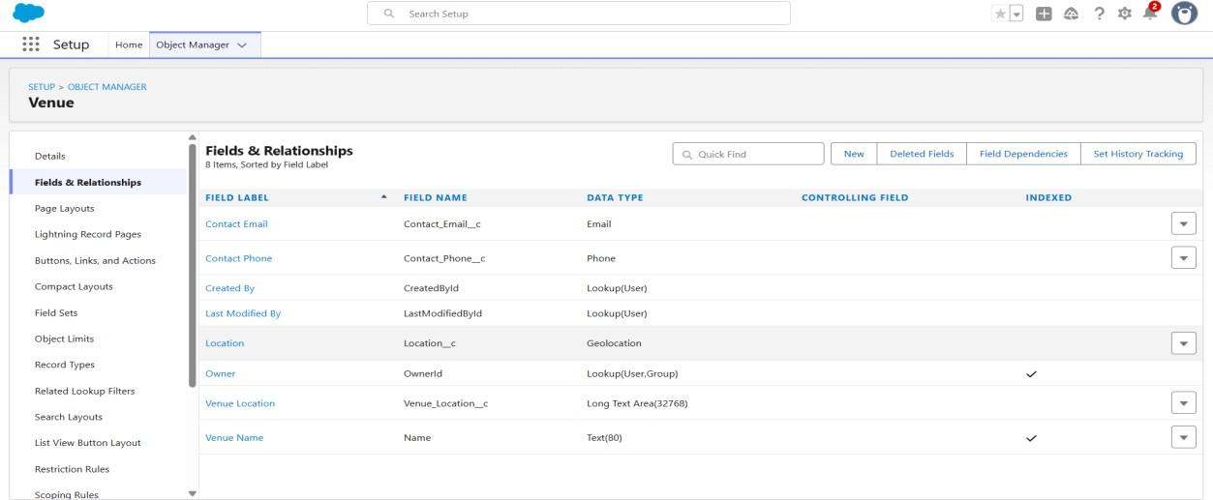
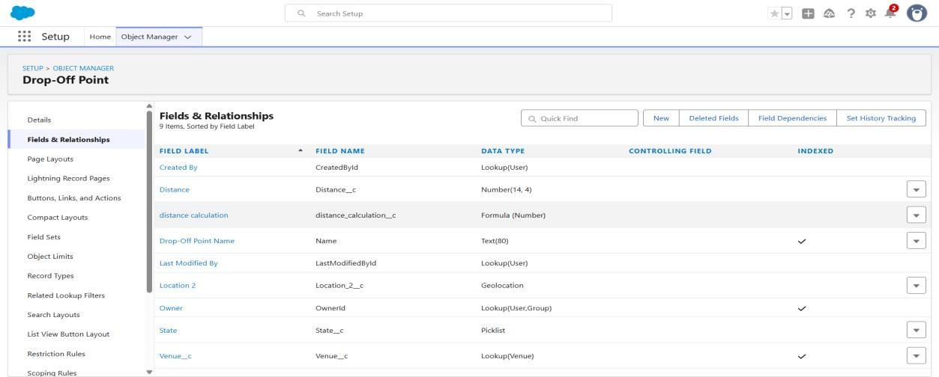

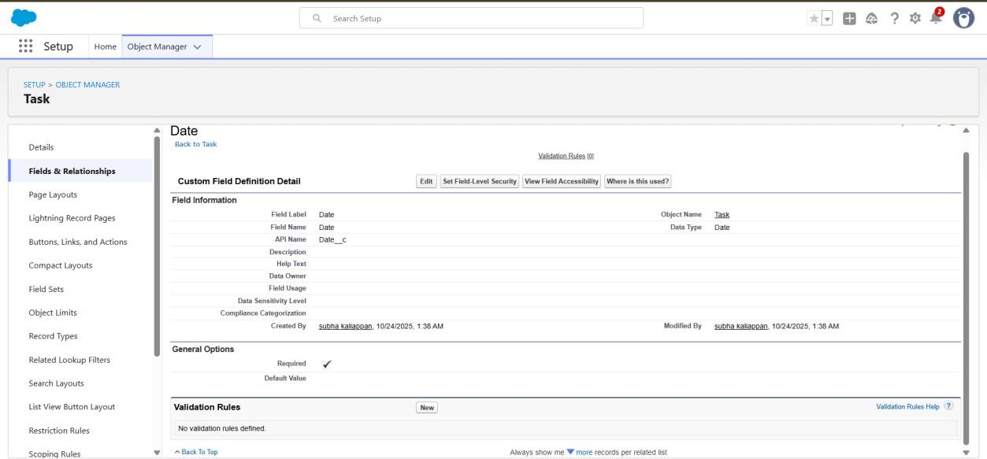

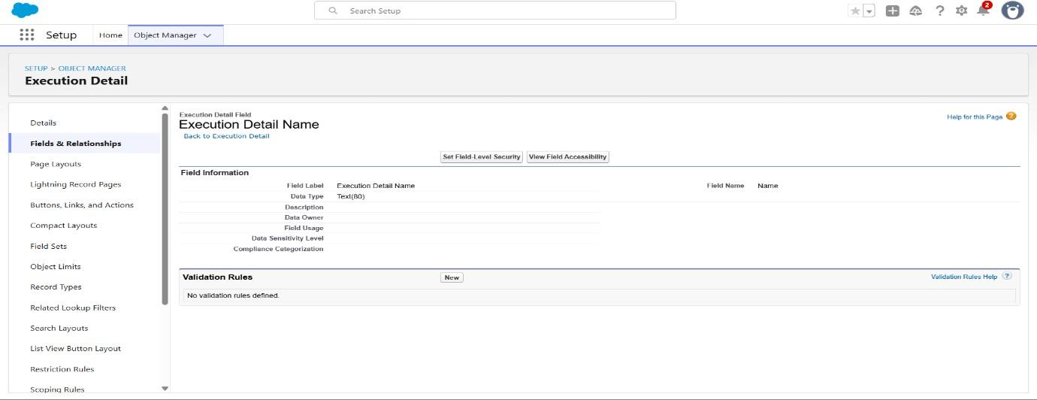
Create Flow to create a record in Venue object:

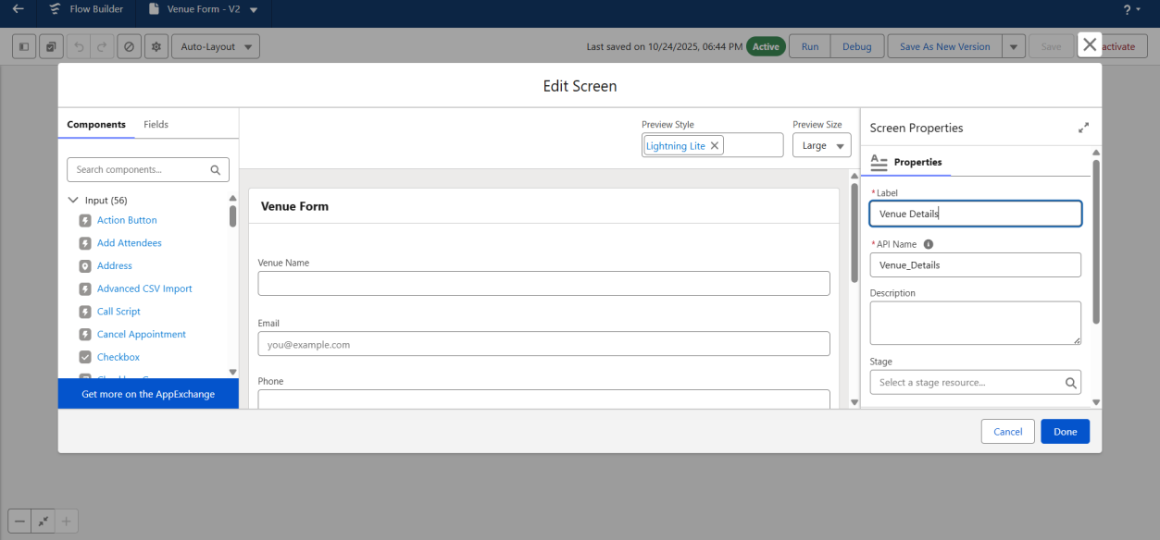

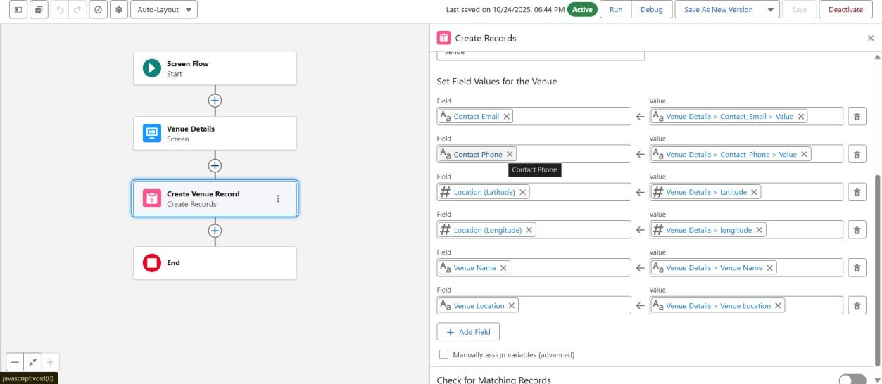
Create a Trigger:
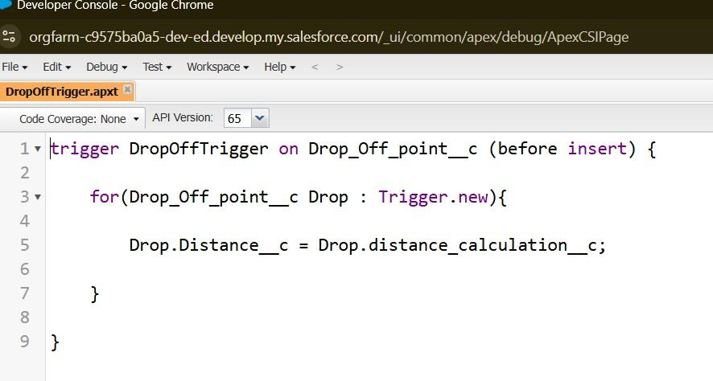

Profiles:
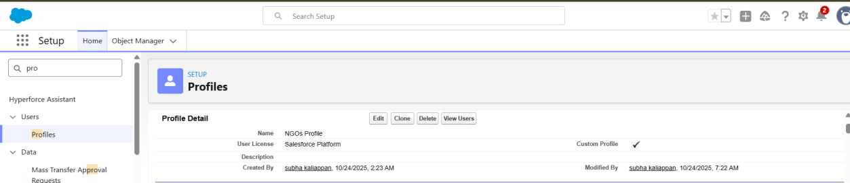
Creation of Users :
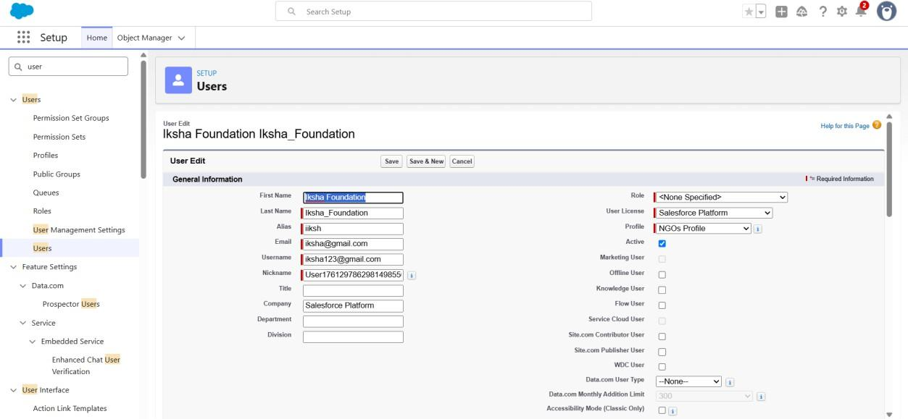
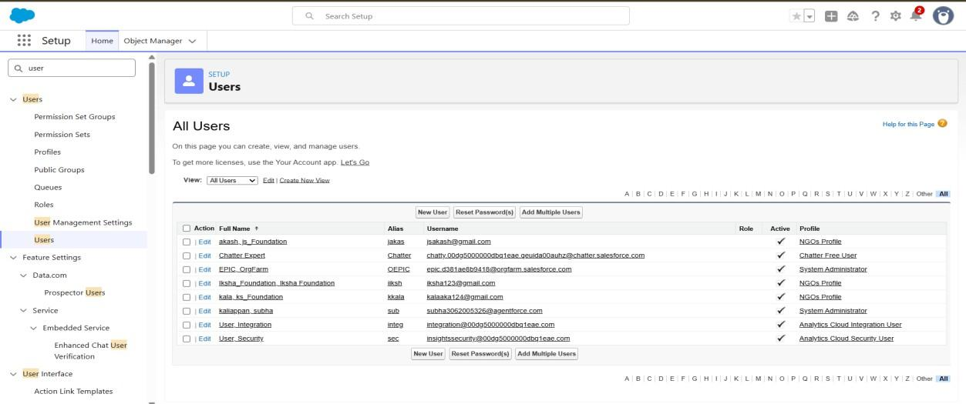

Public Groups:
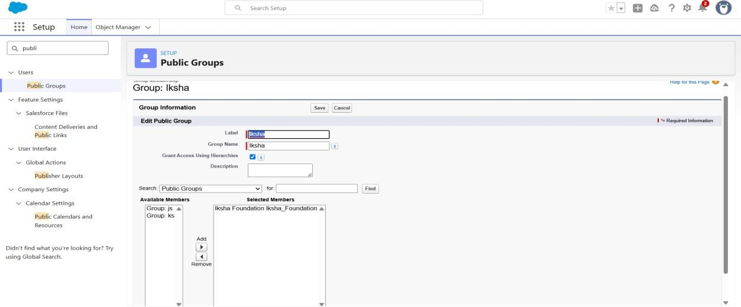

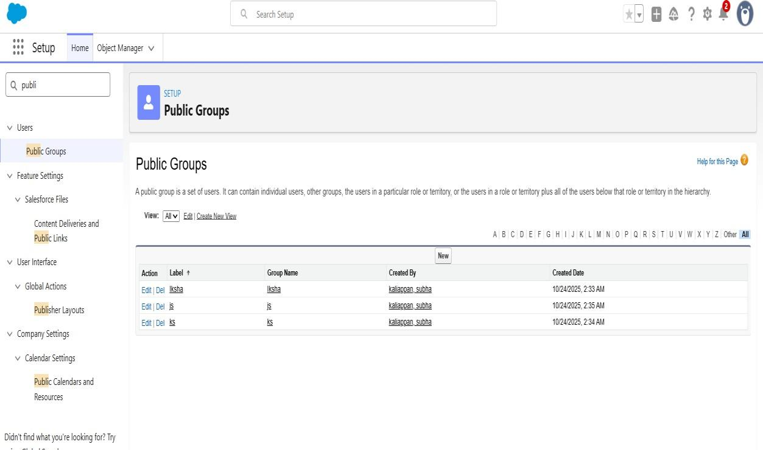
Report Types:

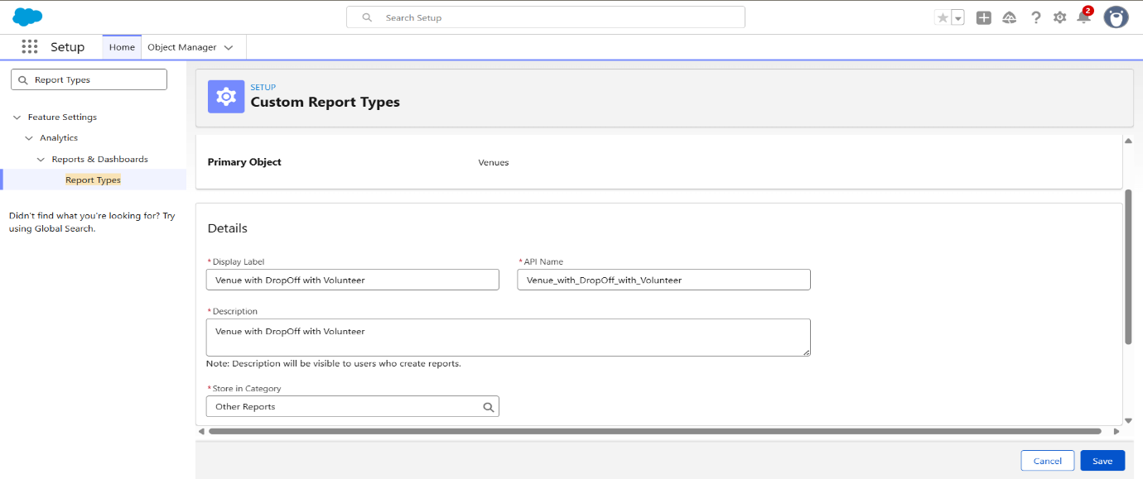

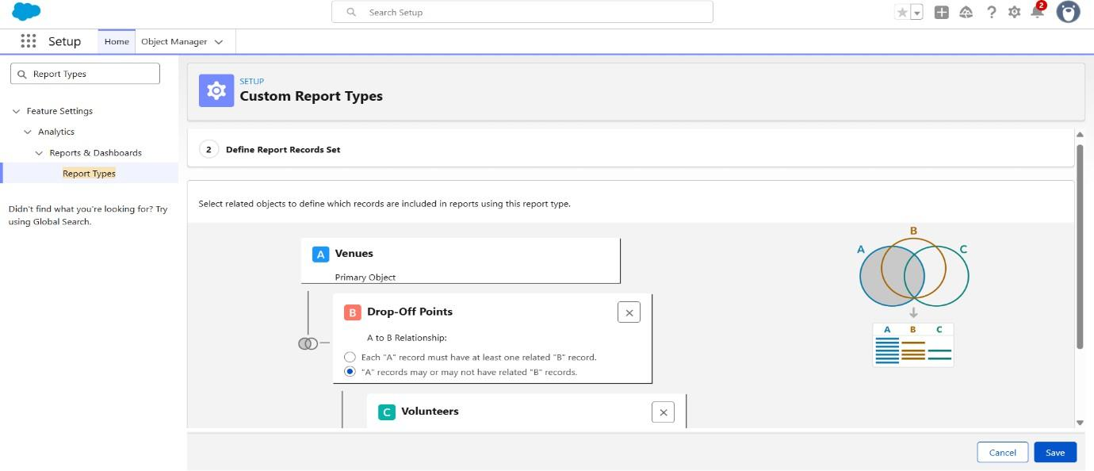
Reports:
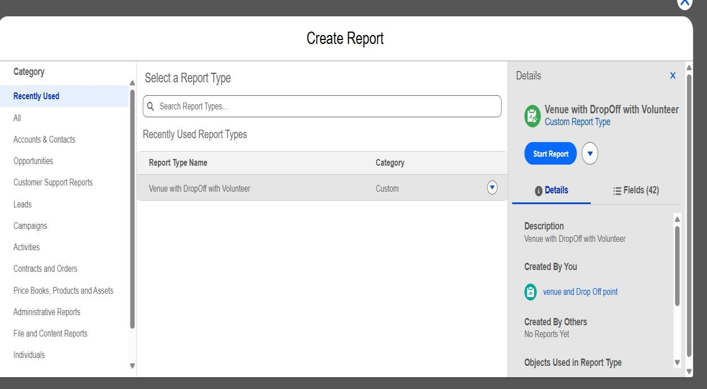
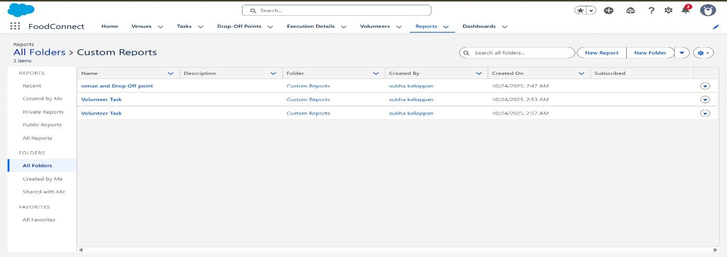
Dashboards:
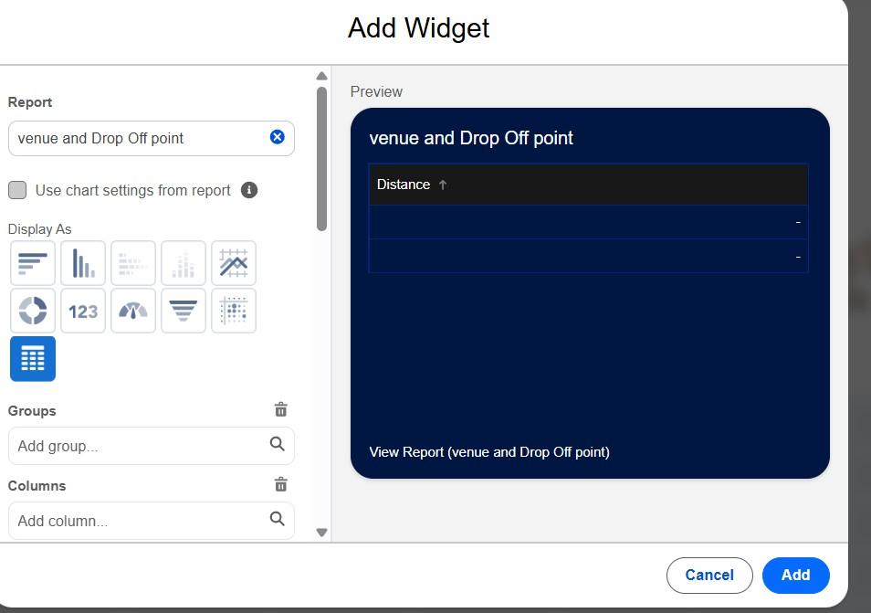

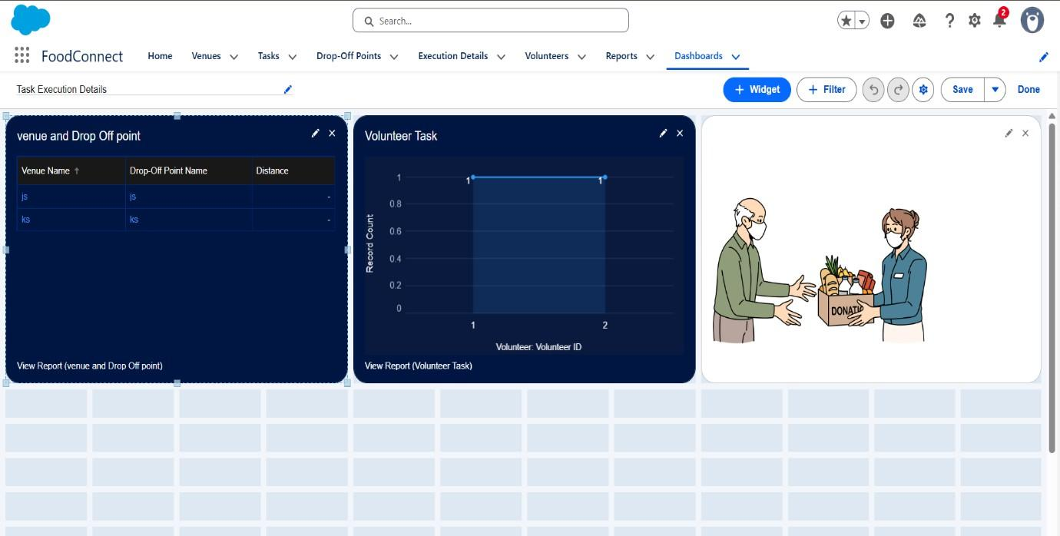
Sharing Rules:

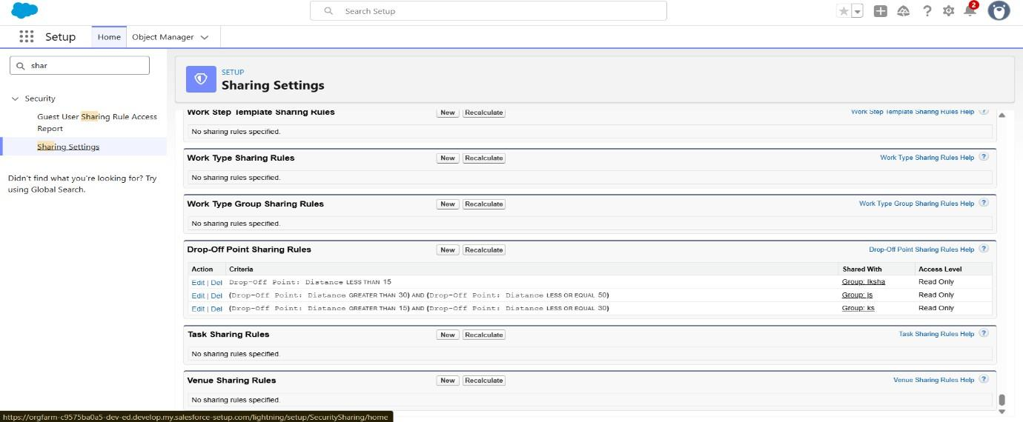
Home Page:

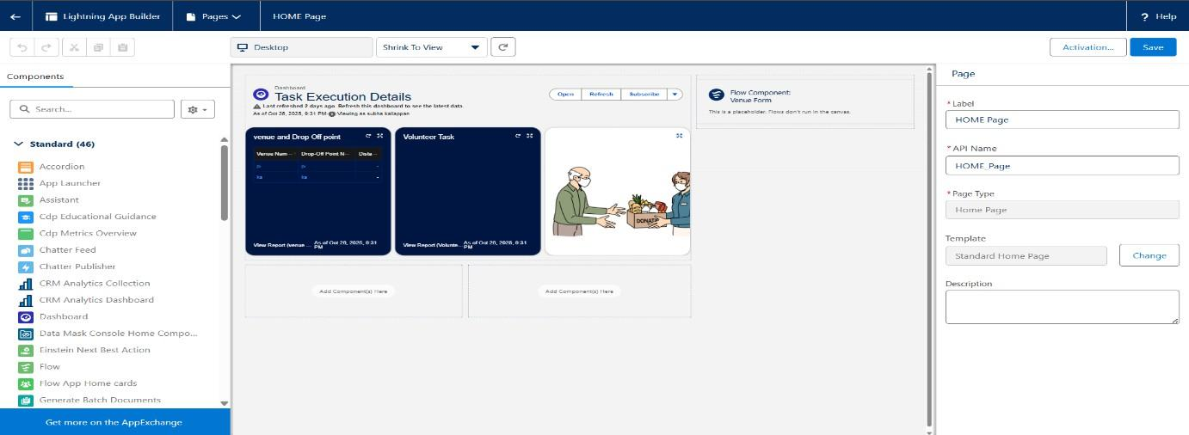

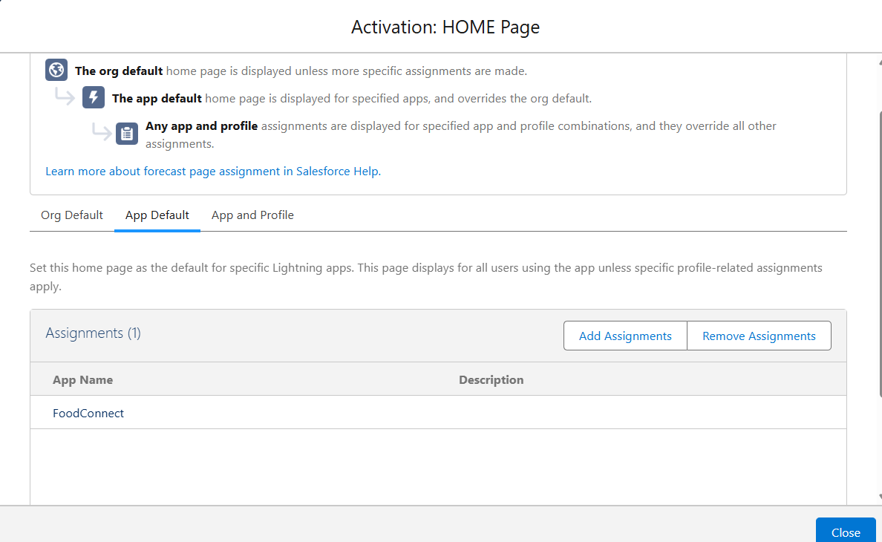
- Performance Testing Phase

In this phase, the complete food supply process is tested to check how well the Salesforce system performs under real-time conditions.

- Venue Adds Food Data:
When a venue (like a hotel or event hall) adds leftover food details, for example 10 plates of rice, the system automatically creates a new Task and assigns a nearby Volunteer.
- Volunteer Updates Status:
Once the volunteer finishes the food pickup and delivery, they update the task status to “Completed.” At this point, an Execution Detail record is automatically generated to confirm the action.
- Drop-Off Point Confirmation:
When the drop-off location (such as an NGO or shelter) receives the food, the system updates the task status to “Delivered.” This confirms successful delivery.
- Report Generation:
The system’s performance is checked by generating a weekly summary report, which should display all completed deliveries quickly — ensuring dashboards refresh within 3 seconds.
Conclusion:

